Name __________________________________ Date _________________________

Lesson #12 – Perimeter and Area of Squares and Rectangles

Directions: Find the perimeter of the following figures by using an equation and solving algebraically.
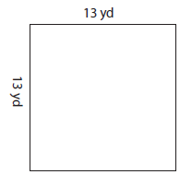
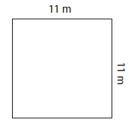
1) 2)

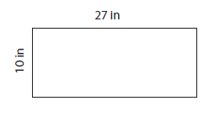
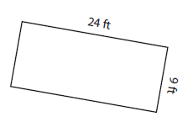
3) 4)

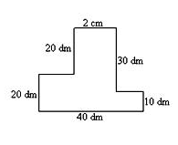
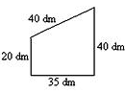
5) 6)

Directions: Find the area of the following figures by using an equation and solving algebraically.
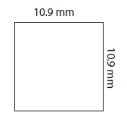
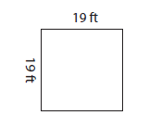
7) 8)

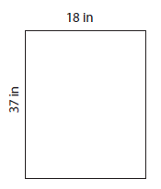
9) 10)

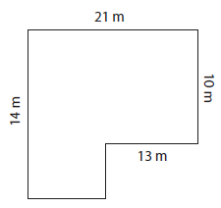
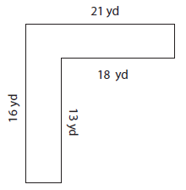
11) 12)

Name __________________________________ Date _________________________

Homework #12 – Perimeter and Area of Squares and Rectangles

Directions: Find the area and perimeter of the following figures by using an equation and solving algebraically.

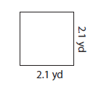
1) Perimeter = _________________
Area = _____________________

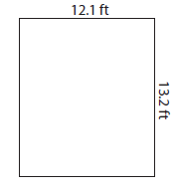
2) Perimeter = _________________
Area = _____________________

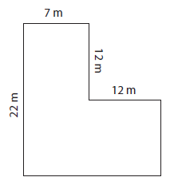
3) Perimeter = _________________
Area = _____________________

